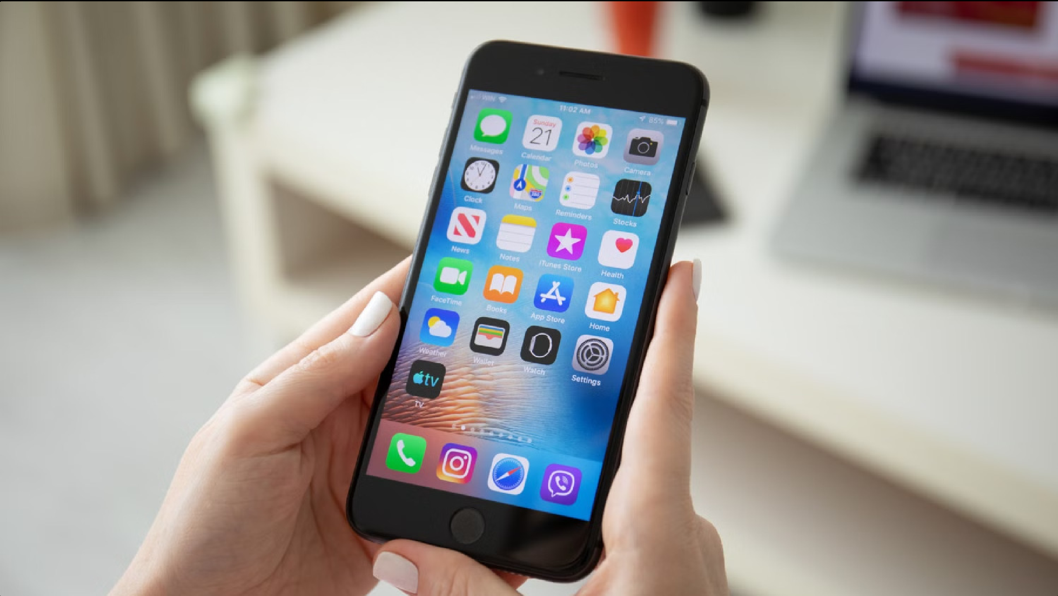

User Journey Map for iPhone

This document outlines the user journey for the iPhone, from initial awareness to long-term loyalty. It examines key stages in the customer experience, including awareness, consideration, purchase, usage, and loyalty. Understanding these stages allows Apple to optimize its marketing efforts, product design, and customer service to drive engagement and satisfaction.

# Awareness: How users discover the iPhone

Awareness of the iPhone is often sparked through a combination of factors:

**Media Coverage:** Apple's iconic product launches and media attention create buzz and generate interest in the iPhone. Tech reviews, articles, and social media discussions amplify the excitement surrounding new releases.

**Word of Mouth:** Existing iPhone users enthusiastically recommend the device to friends and family, spreading positive experiences and fostering trust in the brand.

**Visual Appeal:** The iPhone's sleek design and elegant aesthetics are highly appealing to potential customers. Images and videos showcasing the device's design and functionality often spark desire and drive initial interest.

**Social Media Influence:** Influencers and tech bloggers contribute to the awareness stage by showcasing the iPhone's capabilities and features through engaging videos, product reviews, and tutorials.

# Consideration: Factors influencing iPhone purchase

Once users become aware of the iPhone, they begin to weigh their options and consider factors such as:

1. **Price:** The iPhone's premium pricing is a key consideration for potential buyers. They assess the value proposition and compare it to competing devices in the market.
2. **Features & Functionality:** Users explore the iPhone's unique features, such as the iOS operating system, camera capabilities, app ecosystem, and security features. They compare these to other smartphones and consider which features are most important to them.
3. **Brand Reputation:** Apple's strong brand reputation and perceived innovation play a significant role in purchase decisions. Users often associate the iPhone with quality, reliability, and a seamless user experience.
4. **Ecosystem Integration:** The iPhone's integration with other Apple products, such as Macs, iPads, and Apple Watch, is a major draw for users seeking a cohesive and connected experience.
5. **Availability & Accessibility:** The iPhone's wide availability across retailers and carriers makes it easily accessible for potential buyers. However, limited edition models or specific configurations may present challenges in terms of availability.

# Purchase: The iPhone buying process

The iPhone purchase process is often influenced by a combination of online and offline experiences:

**Online Research:** Users often begin their research online, browsing websites, reading reviews, and comparing prices. They may utilize online tools and forums to gather information and make informed decisions.

**Retail Store Visits:** Brick-and-mortar stores provide a physical experience where customers can handle the iPhone, interact with staff, and get personalized recommendations.

**Online Ordering:** The convenience of online ordering allows customers to purchase iPhones from the comfort of their homes.

**Carrier Partnerships:** Mobile carriers play a significant role in the purchase process, offering bundled deals, installment plans, and trade-in options.

**Customer Support:** Pre-purchase customer support is crucial for addressing questions, clarifying doubts, and providing guidance on specific features or configurations.

# Usage: How users interact with their iPhone

The iPhone's user experience is characterized by:

## Intuitive Interface

1

Apple's iOS operating system is known for its user-friendliness, intuitive design, and easy navigation. Users can quickly learn how to use the iPhone and access various features and apps.

## Seamless Integration

The iPhone seamlessly integrates with other Apple products and services, creating a cohesive and connected experience across devices. Users can easily transfer data, share content, and manage their devices through Apple's ecosystem.

2

Personalized Experience The iPhone offers a highly personalized experience with customizable settings, widgets, and



3

app organization. Users can tailor their device to their preferences and create a unique experience.

## App Ecosystem

The iPhone boasts a vast app ecosystem with millions of apps available for download. Users have access to a wide range of applications catering to their needs and interests, enhancing the iPhone's functionality and capabilities.

4

# Loyalty: Retaining iPhone customers

Apple's efforts to retain iPhone customers involve several key strategies:

**Product Innovation:** Continuously introducing new features, improvements, and design advancements keeps users engaged and excited about the iPhone.

**Software Updates:** Regular software updates provide bug fixes, security enhancements, and new features, extending the iPhone's lifespan and value proposition.

**Customer Support:** Providing exceptional customer support, troubleshooting issues, and resolving concerns builds trust and fosters loyalty.

**AppleCare:** Offering extended warranties and support programs provides peace of mind and ensures customer satisfaction.

**Community Engagement:** Building a strong online community through forums, social media groups, and events allows users to connect, share experiences, and build relationships with the brand.